**Super Servoli Systems**

**Business/User Requirements Document**

**Third draft**

Project: Super Servoli Systems

Author: Hao Dong

**Table of Contents**

Project Overview 3

1.1 Audience 3

1.2 Glossary of Terms 3

Document Information 3

Business Opportunity 4

4.1 Project Overview and Background 4

4.2 Current State Analysis 4

4.3 Future State Objectives 5

4.4 Stakeholders 5

Business Requirements 6

Business Scope 6

Details of Business Requirements 7

Non-functional requirements 10

External Data Feeds 11

Business Risks 11

# **Project Overview**

This document describes requirements for Super Servoli Systems that will be used as the basis for the following activities:

* The system helps to expedite ordering and service
* Allow different types of restaurants like fast-food restaurants, take-out restaurants, pop-up restaurants, bars, concessions, and fast-casual restaurants to customize and adapt the system based on their own requirements
* The system is used by allowing customers to order food, and select the location where they wish to sit throughout the restaurant.
* Deliver web and mobile applications with the paypal payment API. The system has the option of accepting credit cards, debit cards, and cash.

# **Document Information**

**1.1 Audience**

|  |  |  |
| --- | --- | --- |
| **Business Group** | **User Roles** | **Team Member Name** |
| **Restaurants Stores Management** | **Partner Relationship Manager(responsible for local restaurant partners)** | **Poovadol** |
| **Advertisement Sales Management** | **Advertisement Sales Representative**  **Food popularity trend Analyst**  **Recipe Specialist** | **Jaepil** |
| **Subscription/ Account Management** | **Account Manager** | **Hao** |
| **Finance Management** | **Accountant** | **Ryan** |
| **Daily Need Management** | **Daily Need Manager**  **Recipe Specialist** | **Andy P** |

**1.2 Glossary of Terms**

|  |  |
| --- | --- |
| **Term/Acronym** | **Definition** |
| **POS(point of sale)** | **The point of sale (POS) is the time and place where a retail transaction is completed. At the point of sale, the merchant calculates the amount owed by the customer, indicates that amount, may prepare an invoice for the customer (which may be a cash register printout), and indicates the options for the customer to make payment. It is also the point at which a customer makes a payment to the merchant in exchange for goods or after provision of a service. After receiving payment, the merchant may issue a receipt for the transaction, which is usually printed but can also be dispensed with or sent electronically.** |
| **Expeditor** | **Expeditors in upscale or casual dining restaurants ensure kitchen orders are prepared in a timely manner. They check the orders for accuracy and serve as liaisons between cooks, waiters and customers.** |
| **QSR-quick serve restaurant** | **The restaurants which have fast food service like KFC, Wendy’s, Mcdonalds, etc.** |
| **KDS-Kitchen Display System** | **This kind of system that is set up so the kitchen people and chef can see what they need to make and prepare.** |

# **Business Opportunity**

4.1 Project Overview and Background

We aim at providing an app that can be personal customized by the client such as different types of restaurants. The app will help the customers in the restaurant easier to order food, book tables and set-up reservations themselves. And for the restaurants, labor is a huge part of cost. The service would reduce this cost too. Thus, the app is very useful to both restaurant side and customers in the restaurant side. For the payment, the app will be inserted a paypal API for the secure of the transaction. The whole system has the option of accepting credit cards, debit cards, and cash.

4.2 Current State Analysis

Nowadays, the technology of the mobile devices and the internet have been getting really mature. Everybody has a smart phone with a lot of apps installed on the devices. Since the pace of the life in 21 century is getting really fast, people have to spend more time on the work and less time getting and eating food, we created this Super Servoli Systems to help both restaurants and customers in the restaurants to have faster and supreme services. The idea of the app was taken from Evoke (McDonald’s), ConnectSmart Hostess (Red Lobster, Olive Garden), Ribot (KFC), Opentable(Restaurant booking service). The project will be written in JavaScript. The DB will be Google firebase.

4.3 Future State Objectives

The time between a customer placing an order and receiving their food would be shortened significantly along with an easy to use interface to make selections simple. The software simply removes the need to have people tracking orders and instead track it on software. This would greatly reduce errors made in taking someone’s order. Eliminate the need for customers to rely on calling a restaurant to book a reservation.

4.4 Stakeholders

The following table shows stakeholders of Super Servoli Systems.

|  |
| --- |
| Project Team |
| Project Manager |
| Partner Relationship Manager(responsible for local restaurant partners) |
| Advertisement Sales Representative |
| Food popularity trend Analyst |
| Recipe Specialist |
| Account Manager |
| Accountant  Daily Need Manager |

# **Business Requirements**

**Business Scope**

The users of the app will be able to allowing customers to order food, and select the location where they wish to sit throughout the restaurant. The system helps to expedite ordering and service. The system has the option of accepting credit cards, debit cards, and cash.The idea of the app was taken from other food ordering apps.

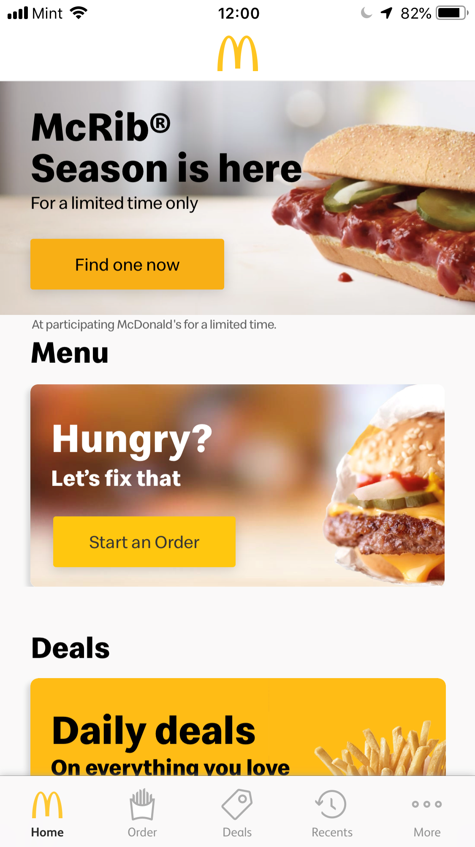

**Details of business requirements**

5.1 Restaurant store management

5.1.1 ability to supply help to any local subscribed restaurant in our system

5.1.2 ability to inform all the emergency information to any local subscribed restaurant in our system in time

5.2 Subscription/Account management

5.2.1 ability to show all subscribed restaurants accounts

5.2.2 ability to manage all subscribed restaurants accounts.

5.2.3 ability to manage employee accounts in all the subscribed restaurants.

5.2.4 ability to manage restaurant account information.

5.2.5 ability to delete restaurant accounts.

5.2.6 ability to deactivate restaurants accounts.

5.2.7 ability to reactivate restaurants accounts.

5.2.8 ability to create restaurant accounts.

5.2.9 ability to sign into an account.

5.2.10 ability to provide account troubleshooting.

5.3 Finance management

5.3.1 Validate card details.

5.3.2 ability to manage all the transactions

5.3.3 ability to accept bill payment from user

5.3.4 ability to display payment status

5.3.5 ability to show the advertisement expenses

5.4 Advertisement Sales Management

5.4.1 ability to make attractive advertisement

5.4.2 ability to facilitate the achievement of current and long-term sales profit and revenue plans

5.4.3 ability to perform duties inclusive of negotiation, and external and internal communication for the purpose of ensuring that all opportunities to drive sales volume are capitalized on

5.4.4 ability to have a keen understanding of the market opportunities for the restaurants

5.4.5 ability to handle all of the business’s advertising campaigns from their conceptualization to their completion

5.5 Daily need management

5.5.1 ability to know what food customers mostly need

5.5.2 ability to know what stuff restaurants mostly need

5.6 customer requirements

5.6.1 ability to download the app from apple store or Google Android store

5.6.2 ability to log into the app by using email address, cell phone or social media accounts

5.6.3 ability to edit the account information in the app or website anytime

5.6.4 ability to report bugs in the app or website anytime

5.6.5 ability to access customer’s location so they can find the nearest restaurant near them

5.6.6 ability to see the real time process of food preparing and making in the app and website

5.6.7 ability to pick any food the restaurant have in the app and website

5.6.8 ability to get the delivery notification from app and website

5.6.9 ability to see the good deals at the front page of the app and website

5.6.10 ability to see the popular combos of the food other customers like mostly at the front page of the app and website

5.6.11 ability to get the coupon after being subscribed customers and finish ordering

5.6.12 ability to check the recent orders so the customers don’t need to waste time to reorder the same thing as before

5.6.13 ability to choose a credit card or cash option after finish ordering food

5.6.14 ability to have tips amount option in the app and website for the delivery men

# 

# **Non-functional requirements**

|  |  |
| --- | --- |
| Category | Requirements |
| Usability | The application's GUI interface should feature a simple and intuitive design, with menu options clearly labeled and field functions obvious to any user. |
| Usability | The purpose of any section of the application should be immediately evident to any user. |
| Usability | The application should be easy to navigate and users should be able to immediately access any significant functionality that they may need within a few clicks, ideally in one click. |
| Performance | The response time of the application should not be impacted by latency that will significantly impact the evident availability of application features or information |
| Performance | TheThe application should be available for users 24 hours a day, every day of the year. |
| Performance | The application should be not make excessive demands on customer's computer or device memory capabilities |
| Performance | The application should support several users using simultaneously. |
| Security | The payment will be secured within the paypal API, so hackers won’t be able to steal the money during the transactions |
| Database | Application will use the google firebase database. |
| External System | Application will be able to interface successfully with social media websites, restaurant service websites, credit card payment services, and other online resources |

# **External Data Feeds**

**Process payments-payment gateway:**

**-Enables customers to charge food they ordered to their provided credit card.**

**-Order processed will have final match the sum of all selected menu items.**

**Display Ads-external ad system:**

**Enables ads to rotate and display while users are browsing the application.**

**Banking information-bank:**

**Validates transactions with external banks.**

# **Business Risks**

If the service of the system got hacked, web crashes occur, the application might not work as expected, this will be the biggest business risk, because it will make the customers of the restaurants stop using their app and instead customers might choose other restaurants which has stable quality service. That means restaurants will lose a lot of customer source and money. It will also makes restaurants decide to choose other stable system to stop the loss in time.